Happy New Year 2025 dear colleagues and friends!
Herein you find a brief review of our latest progresses in activities and an outlook on the upcoming tasks and events for 2025.
We wish you a wonderful year full of success and happiness, and in good health!

Recent activities of the ICP since early 2024 and upcoming events
08/2024 5th meeting of CDM, Copenhagen, Denmark
09/2024 CCE, CDM and ICP M&M Chair attended Joint WGE &EMEP annual meeting in Geneva, Switzerland
10/2024 CCE attended the Informal Delegates Meeting of the Air Convention in Leuven, Belgium (report)
01/2025 CCE Workshop for new and interested NFC representatives (23rd January, online)
02/2025 41st ICP M&M TF, 32nd CCE and 6th CDM meeting in Helsinki, Finland (see below)
03/2025 EMEP SB and WGE Extended Bureau Meeting in Ljubjana, Slovenia

 Save the date 41st ICP M&M TF meeting: 18th – 20th February 2025 in Helsinki, FI
You should have a received an invitation to reserve a date in your agendas for our 2025 Task Force and centers meeting which will be held from Tuesday 18th until Thursday 20th February 2025. The meeting will be held in Helsinki (FI), hosted by the Finnish Environment Institute (Syke) and supported by the Finish Ministry of the Environment. We hope that as many of you as possible will have the opportunity to travel to Helsinki, but there will also be a possibility to participate via a link. Further information is available from the CCE website: Meetings & Workshops | Umweltbundesamt
Any question? @ alice.james@ineris.fr

Outreach activities – informative workshop for EECCA and WB countries
The meeting will be preceded by a short workshop open for Experts from Eastern European, Caucasian and Central Asia (EECCA) and Western Balkan (WB) countries. This workshop will be an introductive and informative meeting to present concisely our work to participants new to the ICP M&M coming from EECCA and WB countries and to learn about data and capacities in those countries. CCE is happy to cover travel and lodging costs of one expert per country. Our wish to make this event happen follows the long-term objective to broaden our networks in EECCA and WB countries and to reduce uncertainties for the science-policy approach of the CLRTAP. For further information please see the letter you have been sent by the Secretariat if you are concerned about this proposed additional meeting which will happen on Tuesday morning.
Any question? @ cce@uba.de ; alice.james@ineris.fr

Workshop for new and interested NFC representatives
During the 40th ICP M&M, TF, 31st CCE and 5th CDM meeting in Oslo new NFC representatives expressed interest to participate in an introductory workshop on empirical Critical Loads and Steady State (SMB) Critical Load modelling. The aim is to inform these new NFC representatives from several countries on the structure and the responsibilities of the Coordination Center for Effects. The meeting is organized by CCE as online meeting January 23rd in 2025. If you are still interested to participate, please do not hesitate to contact us under cce@uba.de.
Any question? @ cce@uba.de

Restructured CCE website

Following the productive survey during the
40th ICP M&M, TF, 31st CCE and 5th CDM meeting in Oslo, the CCE has decided to update the website to improve the information retrieval service. We are pleased to make the restructured CCE website available, including a section providing recent maps and statistics on Critical Load Exceedance data. In addition to that we are still working on a technical solution to include a web map service. We hope that this restructured website will now be easier and more direct to use. If you have any additional suggestions for the CCE website to make it more enjoyable to use, please do not hesitate to contact the CCE.
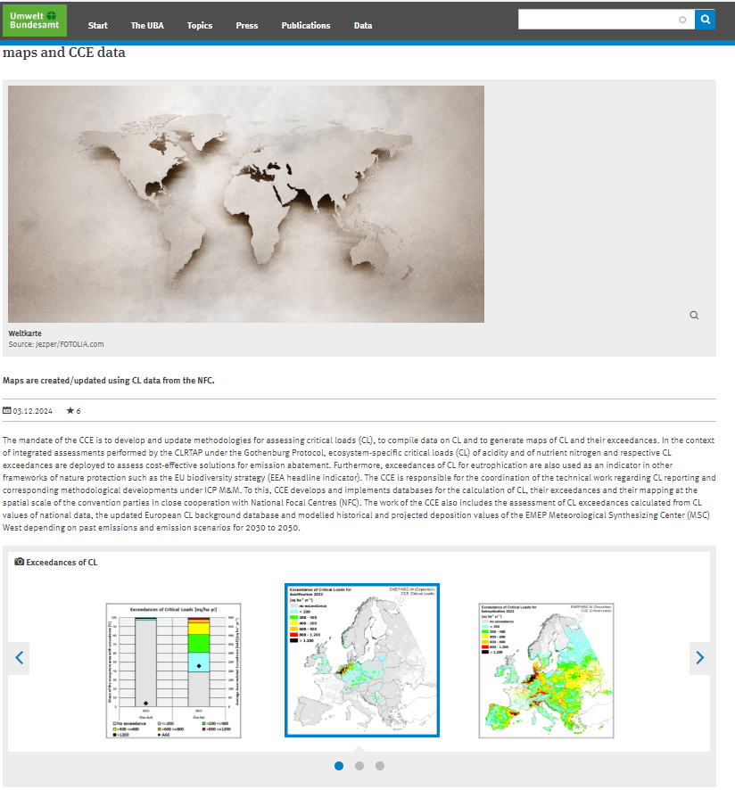

Any question? @ cce@uba.de

Revision of the Gothenburg Protocol
Under the leadership of the TFIAM/CIAM recent data of the ICP Modelling & Mapping, prepared and provided by the CCE, is involved in the integrated assessment modelling of different policy options. To quantify the risk for changes in biodiversity through Nitrogen deposition a European ecosystem specific Empirical Critical Loads dataset (including the EECCA region) was introduced into the GAINS model. For the evaluation of the policy scenarios, either the minimum or the average values of the empirical Critical Loads ranges for 62 ecosystem types have been attributed to the receptor map by the CCE. The assessments show, that even for the stricter minimum values a reduction of 50 % and more of the exceedance of critical Loads seems attainable with the different evaluated policy options. However, the attainability of the 50% reduction target differs among regions and among ecosystem types. The methodology and the results are documented in the “Policy brief on potential targets to reduce risks for health and ecosystems” prepared by CIAM with contribution of CCE. Further information: Item 5_TFIAM_CIAM_Policy_0.pdf

EMEP Status Report (1/2024)
CCE supported the annual EMEP MSC-West Status Report (published 08.2024) with CL exceedance calculation on basis of the latest available dataset of modelled Critical Loads for eutrophication and acidification and the most current deposition data for the year 2022. The share of ecosystems where the critical load for eutrophication is exceeded is 61.2% in 2022. European average accumulated exceedance in the year 2022 is about 228 eq ha−1 yr−1. In contrast acidity exceedances in the year 2022 occur only on 3.3% of the ecosystem area, and the European average accumulated exceedance is about 19 eq ha−1 yr−1. For further information, please consult the EMEP Status Report 2024 (https://emep.int/publ/reports/2024/EMEP_Status_Report_1_2024.pdf) or the data section of the CCE-Website (https://www.umweltbundesamt.de/en/maps-cce-data)

2024/2025 Call for Data of Critical Loads and Dynamic modelling
In October 2024, a new Call for Data was launched by ICP Modeling and Mapping. The main objective of this Call for Data is to provide the most up-to-date national Critical Load data for acidification and eutrophication to be implemented into the policy assessments and scenario calculation for the ongoing revision of the Gothenburg Protocol. Furthermore, the two objectives of the Call for Data regarding Dynamic Modelling are to gather information from the National Focal Centres regarding dynamic modelling of air pollution effects on ecosystems and data sources and availability, and to provide scenario assessments of the impact of air pollution scenarios on ecosystems including impacts on biodiversity.
The submission of the contribution including reports should be delivered to the CCE for Critical Loads and to the CDM for Dynamic Modelling information by 31st March 2025.
Any question? @ cce@uba.de ; cdm@ivl.se

