UBA/FAO Global Partnership Online Webinar

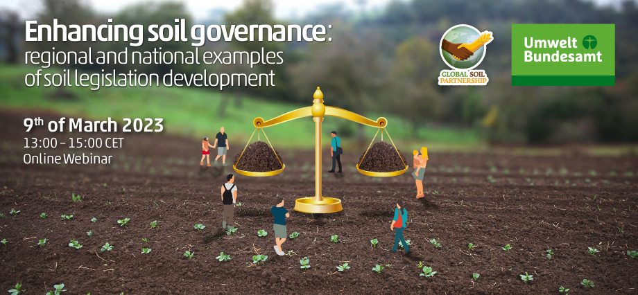

Enhancing soil governance: regional and national examples of soil legislation development

[**Agenda & concept note**](https://www.fao.org/fileadmin/user_upload/GSP/GOVERNANCE/Agenda_2.pdf)**|**[**Recordings of the webinar**](https://www.youtube.com/watch?v=Gco7yZ0nDKU)**|**[**Webinar Report**](https://www.fao.org/3/cc6649en/cc6649en.pdf)

. 13:00-13:10 | OPENING REMARKS

                       Mr Lifeng Li, Director of Land and Water Division, FAO

                       Ms Lilian Busse, Vice President of the German Environment Agency (UBA)

13:10–13:25 | [The Black Soil Protection Law of the People's Republic of China: the importance of the legislation, the process, and the approach](https://www.fao.org/fileadmin/user_upload/GSP/GOVERNANCE/1_Wang.pdf)

                       Prof WANG Jian, China Agriculture University

13:25–13:40 | [Proposal for a global agreement on black soils protection for global food security](https://www.fao.org/fileadmin/user_upload/GSP/GOVERNANCE/2_Vasenev.pdf)

                        Prof Ivan Vasenev, chair of the International Network on Black Soils (INBS)

13:40–13:55 | [Designing a Model law for Africa: regional and national considerations](https://www.fao.org/fileadmin/user_upload/GSP/GOVERNANCE/3_Ginzky.pdf)

                        Dr Harald Ginzky, German Environment Agency

13:55–14:10 | [Soil governance and sustainable agriculture in Mexico](https://www.fao.org/fileadmin/user_upload/GSP/GOVERNANCE/4_Prado_Ortiz.pdf)

To the FAO Webpage on this online webinar, click [here](https://www.fao.org/global-soil-partnership/resources/events/detail/en/c/1631945/)